Project Step 2-Yan Xu

* **Due** Sunday by 11:59pm

Project Selection

 Description

Students select one project from their list to focus on for their project this should include a formal investigation of the requirements of the project.

Background

Students select one project starting from, but not limited to their list to focus on for their project. This should include a formal investigation of the requirements of the project. If possible, identify similar applications that have been written and compare the objectives.

The deliverable is a six to eight paragraph project proposal. This should contain an enough description of the project to allow construction of the project to begin.

**Based on the C # Gobang Development and Design**

Abstract：With the faster pace of life, the game has become an indispensable part of life, which not only makes fun, relax the mood, but also to the development of human intelligence. So, the development of casual games will be the trend, this paper is on the development of Gobang to improve their programming skills.

Gobang game is a simple and popular game, since the computer to achieve, by the love of computer players, but now most popular game soft gobang lack aesthetic interface, and easy method of operation, the value of the computer AI is not high. The adoption of the C# programming language in computer graphics, designed gobang game software to enable the software with a beautiful and friendly interface in both games, the computer has a higher IQ. The game is based on C# language, using searching algorithm to design best gobang. The detailed presentation of the whole process of gobang game software design, describes the software functions and procedures and other gobang other gobang some more.

Key Words：Gobang、C# language、Software

***The reason why I choose this project:***

1. Game is fun.
2. Understand the algorithm behind the Game.
3. Familiar with both of Code edit and GUI design.

***Gobang*** is a two-player abstract strategy game generally played with Go pieces on a 19*19 Go board. Also know by the name Five in a Row.

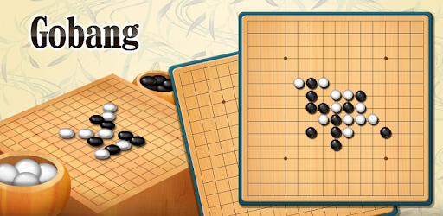The objective of the game is to be the first player to create a sequence of five same-colored pieces vertically, horizontally, or diagonally.

Players alternate turn to place their piece on an empty intersection in the board.

You play by clicking with mouse on any empty field of the board. Then it is turn of Player 2 (in this case Computer). And then it is your turn again and so on.

***Example game 1***

Source: Allis, L. V., Herik, H. J., & Huntjens, M. P. H. (1993). Go-moku and threat-space search. University of Limburg, Department of Computer Science.

[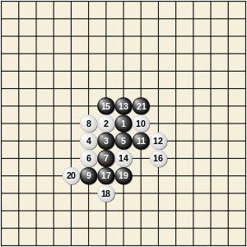](https://en.wikipedia.org/wiki/File:Gomoku-game-1.svg)

First game

This game on the 15×15 board is adapted from the paper "Go-MOKU and Threat-Space Search".

The opening moves clearly show black's advantage. An open row of three (one that is not blocked by an opponent's stone at either end) must be blocked immediately or countered with a threat elsewhere on the board. If not blocked or countered, the open row of three will be extended to an open row of four, which threatens to win in two ways.

White must block open rows of three at moves 10, 14, 16 and 20, but black only must do so at move 9. Move 20 is a blunder for white (it should have been played next to black 19). Black can now force a win against any defense by white, starting with move 21.

[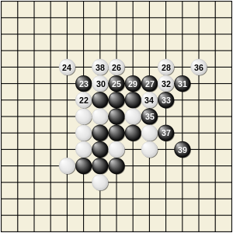](https://en.wikipedia.org/wiki/File:Gomoku-game-3.svg)

Second game (continuation from first game)

There are two forcing sequences for black, depending on whether white 22 is played next to black 15 or black 21. The diagram on the right shows the first sequence. All the moves for white are forced. Such long forcing sequences are typical in Gobang, and expert players can read out forcing sequences of 20 to 40 moves rapidly and accurately.

[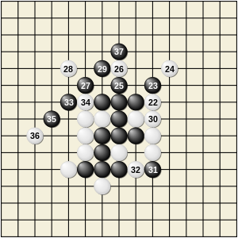](https://en.wikipedia.org/wiki/File:Gomoku-game-2.svg)

Other second game

The diagram above shows the second forcing sequence. This diagram shows why white 20 was a blunder; if it had been next to black 19 (at the position of move 32 in this diagram) then black 31 would not be a threat and so the forcing sequence would fail.

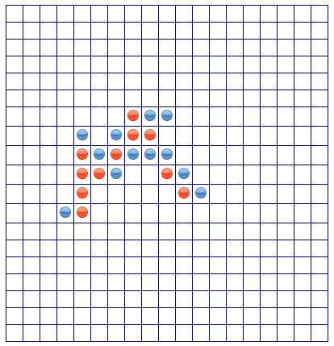***Example game 2***

You can play online by click the link below:

<https://gomokuonline.com/>

See example result as left diagram, and the red side(computer) win the game!

***UI design***

* Picture Box-create the chessboard,20*20.
* Start Button
* Reset Button
* Label-show the game status

***input***

***Module analysis***

The game finishes in one of the following two conditions.

* A player creates a sequence of 5 consecutive pieces vertically, horizontally, or diagonally.
* A player captures 5 pairs of opponent’s pieces.

Start: is the game entry, you can choose the game to be played against

Game: is a game, a game contains a chess record, two players, and a display platform.

human_pk_policy_game: Human players and strategic players battle.

policy_pk_policy_game: Strategy player and strategy player battle.

Chessboard: It is a chess record, which can control the number of rows and columns, given the original chess record (restoration of chess game)

player: is the player, 4 players have been achieved in total.

random_player: play chess randomly

policy_player: Strategy player, calculate the score of each position (offensive score & defense score) through the current game record, and the highest score is used as the final position.

simulate_policy_player: simulate a strategy player to play chess, until the game is over, and the winner is yourself, get the position of the move.

human_player: human players, by entering coordinates in the console, play against other players.

tkinter_human_player: GUI player, by clicking on the position on the chess record of the interface to play against other players (depending on tkinter_display)

display: Display the platform, display the game record and the player's position (at the same time, it also plays the role of urging the player to place), the base class is only responsible for driving the player to place.

print_display: The printer displays the platform and prints the game record of each move on the console.

tkinter_display: TkinterGUI display platform, providing an interface to display the game record.

***Output***

Judge which player(computer) win the game and give out the result.

